

**AS230**

Wellbrook Court | Girton Road | Cambridge | CB3 0NA |

| tel: +44 (0) 1223 279210 | fax: +44 (0) 1223 279253

| email: enquiries@anatune.co.uk | anatune.co.uk

Jonathan Dunscombe, Kathy Ridgway, Phine Banks, Anatune, Cambridge, UK Sarah Gledhill, David Thompson, Thames Water, UK

**Introduction**

**method validation of the analysis of organochlorine pesticides AND POLYCHLORINATED biphenyls using dILLME AND GC-MS/MS**

The use of pesticides, whilst being extremely effective at reducing crop destruction by pests, has caused considerable damage to wider ecosystems and the associated food chains. Although most organochlorine pesticides have been phased out of use due to their toxicity to organisms outside the original scope of application, they still persist in the environment due to their chemical stability. What’s more, concentrations can be significantly increased within apex predators due to bioaccumulation - a problem which can also result in uptake of these compounds within humans. Polychlorinated biphenyls (PCBs) are one such class of organochlorine compounds that have been widely reported to accumulate in the body fat of organisms in the ecosystem. Due to the longevity of these compounds and their extremely toxic nature, several of these compounds, for example dieldrin has a UK regulatory prescribed concentration or value (PCV) of 0.03 µg/L; far lower than 0.1 µg/L for most other organic pollutants. This makes low limits of quantification critical for methods that are employed in the analysis of these compounds.

Today’s well-established methodologies for these purposes require large sample and solvent volumes to reach these low limits and require many hours of analyst time to prepare samples. Whilst these procedures can still have their place, laboratories that are looking to the future to reduce unnecessary wastage, reduce preparation time, reduce costs associated with chemical and consumable usage and increase workflow throughput, can only improve existing methods by investing in newer improved technologies.

Automated dispersive liquid-liquid microextraction is a modified variant of solvent extraction. It is a technique used to extract analytes from an aqueous solution into a small solvent with the help of a dispersing solvent. This solvent, usually isopropyl alcohol, or other similarly polar solvent is added to the sample to aid in the mixing process between the two immiscible liquids; the sample and the extraction solvent, most often dichloromethane or chloroform. With the addition of dispersing solvent, an emulsion is able to form during the agitation process so that extraction of analytes is quick and efficient. To separate the emulsion, the sample is centrifuged, after which a droplet of solvent forms at the bottom of the vial from which a portion is taken and injected into the instrument. Enrichment factors can be in the range of twenty to forty times depending on the volume of sample and solvent used. A video of the automated process can be seen by clicking figure 1.

[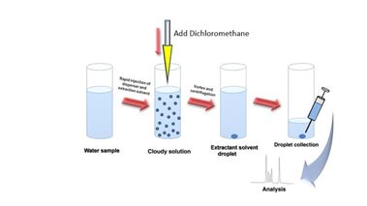](https://www.youtube.com/watch?v=pfgkReU3M9I)

**Figure 1:** Schematic of DiLLME process.

In this application, in collaboration with Thames Water, analysis of several organochlorine pesticides and PCBs in water was carried out with GERSTEL MultiPurpose Sampler capability involving a fully automated dispersive liquid-liquid microextraction (DiLLME) method, coupled with large volume injection (LVI) and analysis using Agilent’s 7010 triple quadrupole mass spectrometer with high efficiency source (HES) to reach the limits required resulting in all compounds being quantified to less than 0.01 µg/L. an NS30 style validation was performed with three duplicate batches to assess precision, bias in three water matrices, with a full eleven duplicate batches for a complete assessment of limit of quantitation.

**Instrumentation**

Dual Head MPS Robotic

GERSTEL QuickMix

GERSTEL CIS 4C

GERSTEL UPCPlus

Anatune CF200 Centrifuge

Agilent GC 7890B

Agilent 7010 QQQ High Efficiency Source

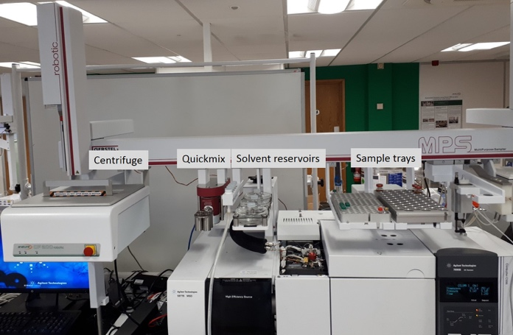

**Figure 2:** Fully automated DiLLME solution.

**Method**

6 mL of sample was transferred to a high recovery vial as a manual step. Following placement of vials onto the system, all standards are spiked automatically using the MPS followed by an aliquot of IPA, then a dichloromethane/pentane mix as the extraction solvent. Samples were then mixed using the GERSTEL QuickMix and separation of the solvent using the CF200 centrifuge. Injection of the samples used 10 µL large volume injection on the cooled injection system. Limits of quantitation were evaluated both on chromatographic data and statistical analysis of variation (ANOVA), with the calibration range of 0 – 200 ng/L. A 10 µL large volume injection was utilised to assist in maintaining good signal at the low levels. Due to the extraction solvent composition, design of experiments (DoE) was used to optimise the injection parameters. Attempts to optimise injection using traditional methods proved unsuccessful due to the complexity of the solvent mix. Details of this experiment are described in application note [AS198](https://www.anatune.co.uk/wp-content/uploads/2018/10/AS198_DoE-on-LVI.pdf). Good sensitivity was also achieved with Agilent’s 7010 triple quadrupole with High Efficiency Source. Table 1 displays the compounds in the suite along with the MRM transitions for each and figure 3 displays the total ion chromatogram at optimised conditions.

**Table1:** Suite of 18 compounds along with internal standards and the MRM used for each.

|  |  |  |
| --- | --- | --- |
| **Compound** | **Retention time (mins)** | **Quant MRM** |
| 1 - HCBD 13C | 9.10 | 223.0->196.0 |
| 2 - HCBD | 9.10 | 223.0->188.0 |
| 3 - Trifluralin d14 | 13.24 | 314.8->267.0 |
| 4 - ɑ-HCH | 13.86 | 181.0->145.0 |
| 5 - β-HCH | 14.50 | 181.0->145.0 |
| 6 - HCH-d6 | 14.55 | 224.0->187.0 |
| 7 - γ-HCH | 14.64 | 181.0->145.0 |
| 8 - δ-HCH | 15.26 | 181.0->145.0 |
| 9 - Triallate | 15.40 | 268.0->184.1 |
| 10 – PCB 28 | 16.12 | 256.0->186.0 |
| 11 - Heptachlor 13C | 16.50 | 346.9->311.9 |
| 12 - Heptachlor | 16.51 | 273.7->236.9 |
| 13 – PCB 52 | 17.06 | 254.9->220.0 |
| 14 - Aldrin | 17.50 | 254.9->220.0 |
| 15 – Heptachlor endo-epoxide | 18.70 | 352.7->316.9 |
| 16 – Heptachlor exo-epoxide | 18.83 | 182.9->118.9 |
| 17 – PCB 101 | 19.70 | 254.0->184.0 |
| 18 - Dieldrin | 20.66 | 278.7->242.9 |
| 19 - PCB 118 | 21.93 | 326.0->256.0 |
| 20 - PCB 153 | 22.68 | 360.0->289.8 |
| 21 - PCB 138 13C | 23.31 | 372.0->300.0 |
| 22 - PCB 138 | 23.32 | 360.0->289.9 |
| 23 - PCB 180 | 24.38 | 394.0->324.0 |



**Figure 3:** Optimised chromatogram at 200 ng/L.

Following development, an NS30 style validation was carried out to assess precision, bias and the achievable limit of quantitation (LOQ) for each of the compounds in the method. This was performed using a range of water matrices supplied: borehole, surface and tap water along with laboratory deionised water as a control. Each matrix was spiked at the approximate LOQ level, being 10 ng/L, a mid-range spike at 20 ng/L, close to the prescribed concentration or value (PCV) for those compounds that have a lower permitted value and 80% of the calibration range at 160 ng/L. ANOVA calculations were used to assess the LOQ along with the precision and bias of the method. Under the regulatory conditions that would be applied to this method, LOQ is calculated as ten times the within batch standard deviation.

**Results**

Linearities were measured for all batches, with r2 values of 0.990 or greater be expected. Figure 4 displays the calibration for heptachlor endo-epoxide and dieldrin with values of 0.997 and 0.998 respectively with a linear graph including the origin.

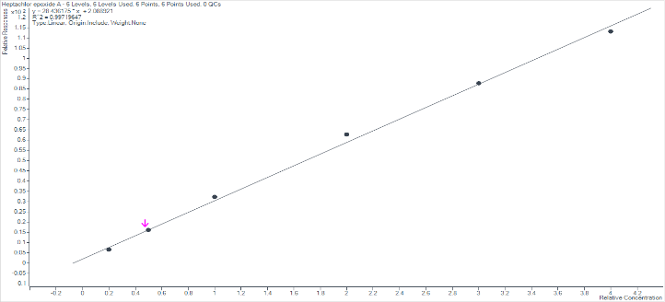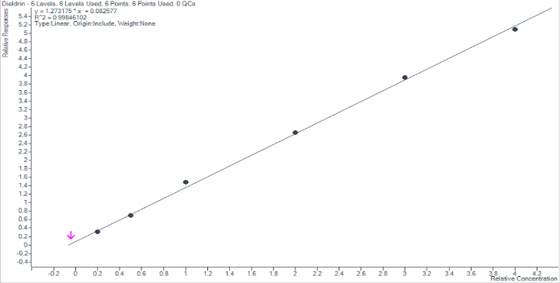

**Figure 4:** Calibration graphs for heptachlor endo-epoxide (top) and dieldrin (bottom). R2 of 0.997 and 0.998 respectively.

To assess sensitivity of the method, samples at a concentration of 10 ng/L were prepared. For an adequate limit of quantitation, a signal to noise value of at least 5 is required. However, regulations in the water industry require that limit of quantitation is calculated as ten times the within batch standard deviation. For the five compounds in the suite that require an LOQ of 9 ng/L (aldrin, heptachlor, heptachlor epoxides and dieldrin) signal to noise values for the quantifier transition were all significantly greater than 5. Limits of quantitation were calculated for all analytes with values of 6.7, 5.2, 5.5, 7.7 and 6.2 ng/L respectively meeting the required target.

Figure 5 shows the quantifier MRM for aldrin, heptachlor exo-epoxide and dieldrin at 10 ng/L with the corresponding blank chromatogram.



**Figure 5:** Chromatograms and signal to noise values for aldrin, heptachlor exo-epoxide and dieldrin at 10 ng/L.

To formerly assess LOQ and method performance, a full eleven batches were analysed in duplicate for all spike levels in tap water provided; this covers a treated final water. Figure 4 displays the recoveries at the three spike levels: 10, 20 and 160 ng/L for γ-HCH, aldrin, dieldrin, heptachlor and triallate. At 20 ng/L, recoveries of -3.1%, -0.1%, -0.6%, -2% and -2.4% respectively were observed falling well within the 25% stated regulations published by the Drinking Water Inspectorate. Figure 6 shows this data for the aforementioned compounds.



**Figure 6:** Recovery for γ-HCH, aldrin, dieldrin, heptachlor and triallate at the three spike concentrations.

Precision values were calculated for all compounds using the validation collected using ANOVA. Table 2 displays this data for each compound at the 20 ng/L spike level, along with the calculated LOQ which was calculated from within batch standard deviation at 10 ng/L. At this level, δ-HCH showed the highest variation at 28.5% which would be above the regulatory limit. This could be rectified by using a δ-HCH 13C labelled internal standard which would behave in a similar manner.

**Table 2.** Calculated LOQs and precision for all 18 compounds.

|  |  |  |
| --- | --- | --- |
| **Compound** | **LOQ, ng/L** | **Precision at 20 ng/L** |
| HCBD | 5.1 | 10 |
| ɑ-HCH | 4.7 | 13.7 |
| β-HCH | 6.8 | 12.1 |
| δ-HCH | 8.7 | 28.5 |
| γ-HCH | 5.8 | 17.2 |
| Aldrin | 6.7 | 24.8 |
| Dieldrin | 6.2 | 20.9 |
| Heptachlor | 5.2 | 17 |
| Heptachlor endo-epoxide | 5.5 | 21.5 |
| Heptachlor exo-epoxide | 7.7 | 19.5 |
| Triallate | 7 | 23.7 |
| PCB 28 | 3.4 | 15.2 |
| PCB 52 | 5.1 | 16.1 |
| PCB 101 | 3.5 | 13.9 |
| PCB 118 | 7.8 | 19 |
| PCB 138 | 5.2 | 15.5 |
| PCB 153 | 4.7 | 16.2 |
| PCB 180 | 5.8 | 15.9 |

**Conclusion**

This work has demonstrated that the regulatory limits that are imposed can be met by using current and up-to-date technology. Regulatory limits of quantitation that were once only achievable through the extraction of large volumes of sample are now accessible with reduced sample sizes with 6 mL for this method a potential forty times decrease on sample volume when compared to methodologies using 250 mL of sample. Use of automated technology for these tasks provide extra benefits:

* Reduced sample transport costs
* Reduced chemical usage
* Potential higher throughput
* Reduced health and safety associated risks

Use of design of experiments software as used for development of a large volume injection method as used for this work also displays the benefits of automation in reducing method development time and also the costs associated with a trial and error approach.

Drinking Water Inspectorate regulations have a precision and bias target of 25% for these compounds; this work demonstrating that these limits can be met.

As the extraction method used covers a wide range of analytes, this has the potential to consolidate many existing methods into one over-arching technique that can then be used for many analyses, again reducing cost and development time.