Large volume injection of Flame retardants using the CIS-4 inlet

# Neil Donovan and Paul Hollis, i2 Analytical., Watford, Hertfordshire, UK.

# Dan Carrier and Jeff Stubbs, Anatune Ltd., Girton, Cambridgeshire, UK

## Introduction

The second round of the chemicals investigation programme (CIP) started in 2015 and continues the study from previous programmes into the spread of low level pollutants across Britain’s waterways.  The analysis covers a vast array of compounds from PAHs, Pesticides, Pharmaceuticals, Plasticisers and Flame retardants in surface waters, waste water treatment work effluents and influent. This Application note looks at brominated flame retardants, specifically the PBDEs or Poly Brominated Diphenyl Ethers; PBDE 28, PBDE 100, PBDE 47, PBDE 99, PBDE 153, and PBDE 153.

i2 Analytical have recently purchased a Cooled Injection System 4 (CIS-4) from Anatune which enables them to perform large volume injection to get down to the detection limits they require. The CIS-4 offers fast and accurate temperature control from 10 oC to 350 oC.

For this method, 10 µl hexane is injected at 45 oC. The inlet temperature is kept at this temperature until the hexane is evaporated from the inlet liner and the inlet is then rapidly heated to desorb the flame retardants off the liner on to the GC column. For this application, a Universal Peltier Cooler (UPC) was used for effective cooling of the inlet. Figure 1 shows a picture of a CIS-4 inlet.

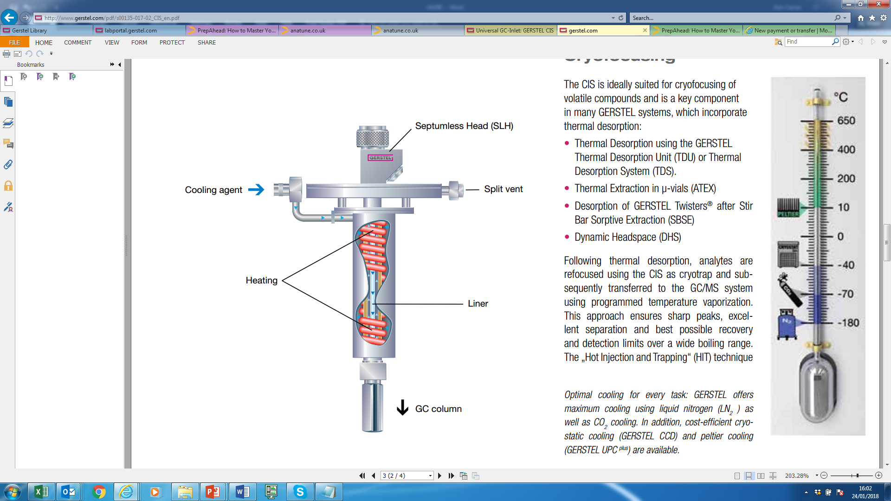

Figure 1. Illustration of CIS-4 inlet

Anatune installed the CIS-4 on an Agilent GC/QQQ 70010 in October 2017 and it is in routine use at i2 Analytical. Figure 2 shows the system set up at i2 Analytical.

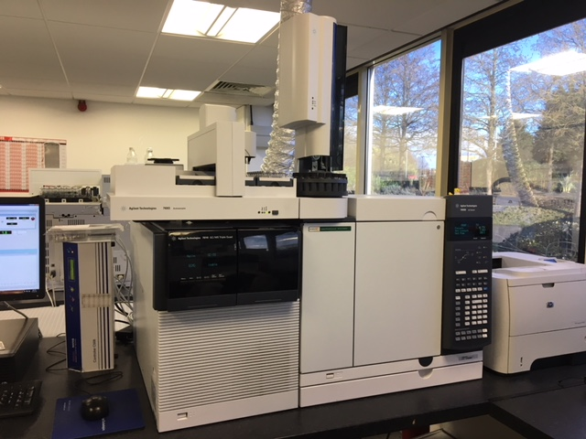

***Figure 2. GERSTEL CIS-4 with*** ***Agilent GC/QQQ 7010 at i2 Analytical.***

## Instrumentation

GERSTEL CIS-4 Cooled inlet System

GERSTEL Universal Cooling System (UPC)

Agilent Technologies GC/QQQ 7010 and 7890B GC

## Method

Standards of the flame retardants were prepared in hexane at 0 ,50, 100, 250, 500, 1250, 2500, 5000, and 7500 ng/L. 13C isotopes were used as internal standards.

Samples were extracted with hexane after spiking with 13C isotope versions of the compounds of interest.

10 µL large volume injection of the hexane extracts was performed with a thermal gradient from 40 oC to 350 oC on a DB 5MS 30 M 0.25 mm id column.

Analysis was performed on a GC-QQQ in MRM mode.

## Results

Figure 3 shows the linearity plot for PBDE 28.

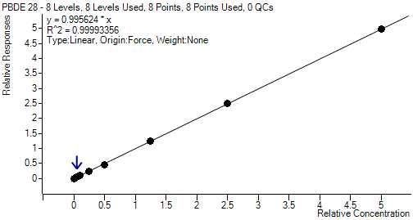

***Figure 3 – Linearity for PBDE 28 (8 point calibration from 50 ng/L to 7500 ng/L, equivalent to 0.1 ng/L to 15ng/L in the samples)***

Table 1 shows linearity r2 values for the flame retardants.

|  |  |  |
| --- | --- | --- |
| **Analyte** | **Retention time (min)** | **r2** |
| PBDE 28 | 11.4 | 0.99993 |
| PBDE 47 | 13.1 | 0.99992 |
| PBDE 100 | 14.5 | 0.99989 |
| PBDE 99 | 14.9 | 0.99997 |
| PBDE154 | 16.1 | 0.99973 |
| PBDE153 | 16.8 | 0.99983 |

***Table 1. Linearity values for the flame retardant extracts.***

Figure 5 shows the Qualifier MRM chromatogram for PBDE 28

(Retention time 11.4 minutes) at the lowest calibration level (50ng/L, equivalent to 0.1 ng/L in the samples)



***Figure 5 – Qualifier MRM Chromatogram PBDE 28***

The signal to noise has been calculated to be 144.1 for the lowest calibration level.

Figure 6 shows the Qualifier MRM chromatogram for PBDE 100

(Retention time 14.5 minutes) at the lowest calibration level (50 ng/L, equivalent to 0.1 ng/L in the samples)



***Figure 6 – Qualifier MRM Chromatogram PBDE 100***

Table 2 shows the precision achieved (corrected with internal standard) from running over 100 AQC spiked samples in effluent matrix (4ng/L).

|  |  |
| --- | --- |
| **Analyte** | **% RSD** |
| PBDE 28 | 6 |
| PBDE 47 | 6 |
| PBDE 100 | 9 |
| PBDE 99 | 6 |
| PBDE 154 | 8 |
| PBDE 153 | 9 |

***Table 2. Precision achieved from over 100 AQC spiked samples***

## Discussion

i2 Analytical now have a sensitive and robust large volume injection method which they are now running routinely on their system.

The fast cool down times using the GERSTEL CIS-4 have meant that i2 Analytical have made a significant time saving to their analysis. This has seen up to a 30% time saving compared to i2 Analytical’s previous Large Volume Injection method.